**Docker Setup-Usage document**

**What is Docker ?**

Docker is a platform for developing, shipping and running applications using container virtualization technology.

**Introducing Containers :**

Container based virtualization uses the kernel on the host’s operating system to run multiple guest instances. Each guest instance is called a **container**.

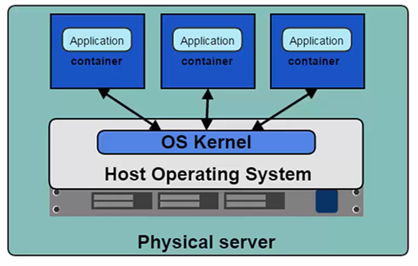

**How to Install Docker :**

*In Linux* –

* Ubuntu : Apt-get install docker
* Fedora : Yum install docker

*In Windows* –

To interact with the Docker Daemon or the host, we can use windows Powershell. Microsoft Hyper virtualization has to be enabled and then follow the below link to download -

<https://docs.docker.com/docker-for-windows/>

*Kitematic* – It is the Docker GUI which runs on OS like Windows and macOS.

<https://kitematic.com/>

**Some Basic Commands :**

**To run docker daemon or client service provider** :

Sudo service docker start

**To check the available images on our local machine :**

Docker images

**To check running containers on our machine :**

Docker ps

Docker ps -aq # Displays running as well as stopped containers

**Start/Stop containers :**

Docker start <container ID or name>

Docker stop <container ID or name>

**Remove images/containers :**

Docker rmi <image name:tag / image ID > # Removing local images

Docker rm $(docker ps -aq) # Removing running as well as stopped containers

**Pulling and Pushing our images**

*How to pull Docker images from docker hub -*

Docker login # login to the docker hub

Docker run images # To pull the image and instantly run the containers

Docker pull images # For pulling the image only

*How to push Docker images to Docker hub -*

Docker push image

**Committing a container** **for saving its state into an image**:

Docker commit <container ID > <user id>/<image>:tag